Weekly Report

Tengteng Tao

9/4/2018-9/11/2018

Goal:

Using the theoretical formula to fit the RHEED line profile from a WS2/sapphire sample at azimuth angle equals to 0 $°$.

Plot:

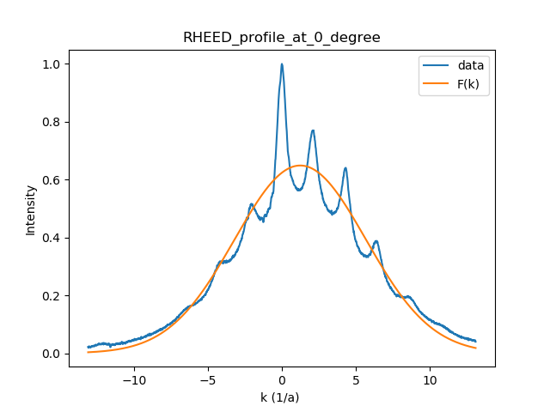

The x axis stands for $k_{∥}$ in the unit of $Å^{-1}$.

The y axis stands for intensity in arbitrary unit.

Variance = 0.0039018832072659614

|  |  |  |  |  |  |
| --- | --- | --- | --- | --- | --- |
| $$ξ$$**($Å$)** | A  arbitrary unit | B  arbitrary unit | $$X_{C}$$ $${(Å}^{-1})$$ | $$σ$$**($Å^{-1}$)** | $$φ$$**degree** |
| 1.920 | -2.938 | 0.649 | 1.241 | -4.432 | -480.543 |

|  |  |  |  |  |  |  |  |  |
| --- | --- | --- | --- | --- | --- | --- | --- | --- |
| x1 | x2 | x3 | x4 | x5 | x6 | x7 | x8 | x9 |
| -538.72 | 606.78 | -933.66 | -1397.3 | 457.64 | 5720.6 | 3445.3 | -173.90 | -1701.8 |

Conclusion:

I wrote a program which used the curve fit to fit the data. However, this program can not fit the data accurately. Only two parameters that I got are in the expected range. The variance also can not show the performance of the model. In order to increase the accuracy, I will use the package least_squares instead of curve fit.